Social Health Insurance
Talk at the Galen Centre. 20/10/2018

First of all I would like to thank the Galen Centre for inviting me to share my views on Health Insurance with you.

Introducing some form of revenue collection from the rakyat to help defray health care costs has been on the Government’s agenda since the 1980s. They have toyed with the idea of a special health tax, separate Health Financing Authority, a payment system that covers both the public and private sector, and other related issues, but so far, despite many studies, no definite plans have been finalized.

This present episode of sponsoring health insurance for the B40 appears to have started from the “Peduli Sihat” Scheme that was implemented by the Selangor Government in 2017. That is scheme which provides families with a household income of RM 3000 and below a debit card which will pay for treatment at any private health care facility in Selangor up to a maximum of RM 500 per year per family, limited to RM 50 per treatment episode. This idea was incorporated in the Pakatan Harapan Manifesto which listed this “Peduli Sihat” scheme as one of the 10 targets for the first 100 days.

However the idea seems to have morphed into something bigger and more harmful. In August this year, the new Health Minister YB Dr Dzulkifli Ahmad announced that the government would introduce a “Social Health Insurance” for the B40 families, and that these families would not be asked to pay towards the scheme. This insurance will pay for a total of RM10,000 worth of treatment in Private Hospitals for that family for one year. According to Dr Dzul, this new plan will be rolled out in January 2019.

Impact on Federal Health Budget
We now have about 7.5 million households in Malaysia. 40% of that would be 3 million families. If all of them were utilize their entitlement to insurance cover, that would come to whopping RM 30 billion for a year. (3 million x RM 10,000). This is bigger than the Federal Health Budget for 2018 – RM27 billion. Of course not every family will use their entitlement in a year, but we should not underestimate the innovative approaches that private hospitals might take to milk this cash cow! Patients can be easily persuaded or frightened into getting themselves admitted for scopes, MRIs and angiographies as there is a huge asymmetry in knowledge between patients and their doctors. Health expenditure will go up, but it may not really add appreciably to better health for the population.

YB Dr Lee Boon Chye, the Deputy Minister of Health, commented a few days later, that families that wished to do so could purchase additional cover if they wished.

Types of Insurance Schemes
But things are not all that simple. There are many kinds of health insurance. Let’s look at 2 aspects –
1. How are insurance payments to be determined? Will insurance premiums be community rated? This means that every family pays an amount irrespective of the medical history of the family members. This is the system adopted in South Korea, where people have to pay 5% of their income to the insurance fund.
2. Will there be a single not-for-profit insurer as there is in South Korea, or will it a number of private companies competing with each other for the market as is the case in Malaysia now? And in Malaysia the premiums are risk- rated. In other words if you have diabetes, or if you have a history of certain illnesses, then your premiums will be higher.

The S Korean System: The National Health Insurance Corporation is the main supervising institution.
- Employed contributors are expected to pay 5.08% of their income
- Self-employed contributions are calculated based on the income and property of the individual.
- The national government provides 14% of the total amount of funding and the tobacco surcharges account for 6% of the funding.
- The total expenditure on health insurance 7.1% of GDP in 2014.^{[19}

Physician Compensation
The second issue that we have to consider is how this insurance scheme will compensate the health care provider. There are 2 ways this is done – one is by a fee for each service provided. The other is by a capitation scheme. The UK GP system is by capitation – each GP is allocated a number of patients to look after, and the GP is paid monthly by the number of patients he is looking after whether or not they come to see the GP that month. One benefit of the capitation system is that it makes sense for the GP to do health education so his patients’ chronic conditions are well under control so they do not develop complications that require them to come and see him/her.

The fee-for-service system pays the health care provider based on the number of visits, procedures, type of intervention that he provides. If not properly audited patients may end up being over investigated and subjected to procedures and operations that they might not really need.

Example 1: For child presenting with pain in the right lower quadrant of the abdomen, mesenteric lymph node inflammation has to be considered as the differential diagnosis to appendicitis. But as charges for managing the former conservatively are much less than operating as the latter, a fee-for-service will influence doctors to go for the latter diagnosis.

Example 2: Not all patients who present with chest pain need an angiogram, especially if the pain is not related to exertion and there are no other risk factors. But reassuring a patient is not as lucrative as performing an angiogram – and quite a few doctors will succumb to that temptation.

Some of this is already occurring in the private sector in Malaysia. And there are many other examples.

Impact on Quality of Care in Government Hospitals
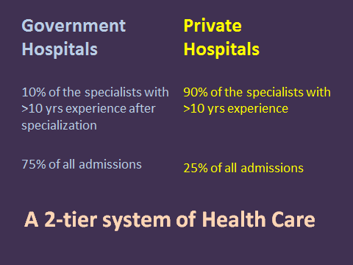

The slide above demonstrates how the development of private hospitals has undermined the public health care system. We already have a 2-tier health care system in Malaysia where those who can pay for treatment in private hospitals get to meet specialists promptly and get treatment much faster than those relying on the government hospitals. This is one of the reasons why several health activists are alarmed by the Health Minister’s enthusiasm in pushing for this new insurance scheme without taking more time to evaluate all its potential ramifications. We are anxious that the following set of events will be set into motion –

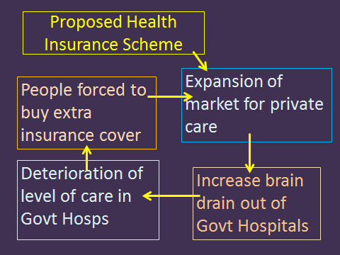

The PSM believes that at this point in time we need to take every step to preserve and strengthen the Public Health Care System in our country. We feel that, in addition to playing an important role in treating the sick, it also builds a sense of social solidarity among the different classes of people in this country, reduces anxieties regarding catastrophic illnesses and old age, and creates the conditions for people to be more generous to each other. In short it makes Malaysia a more happy and harmonious society.

PSM’s call
1. Submit the Health Insurance idea to much more scrutiny and discussion before taking any definite decision. We would be doing a disservice to the poorer half of the population if we were to rush to implement this new insurance.

2. Increase the Federal Health Budget in stages over the next 5 years to 4.0% of GDP from its current 2.2%. Use the extra funds to
- Build a second General Hospital in all our State Capitals that have over-crowded wards.
- Provide plates, screws, operating staplers, cataract lenses, drug eluting stents with minimum co-payments.
We claim to be aspiring to be a high income country. Britain, with its per capita GDP of USD 44,100 (PPP) spends 9.9% of GDP on health care while we on USD 29,000 per capita spend only 4% of GDP overall (Public and private). (GDP figures for 2017 from CIA World Factbook)
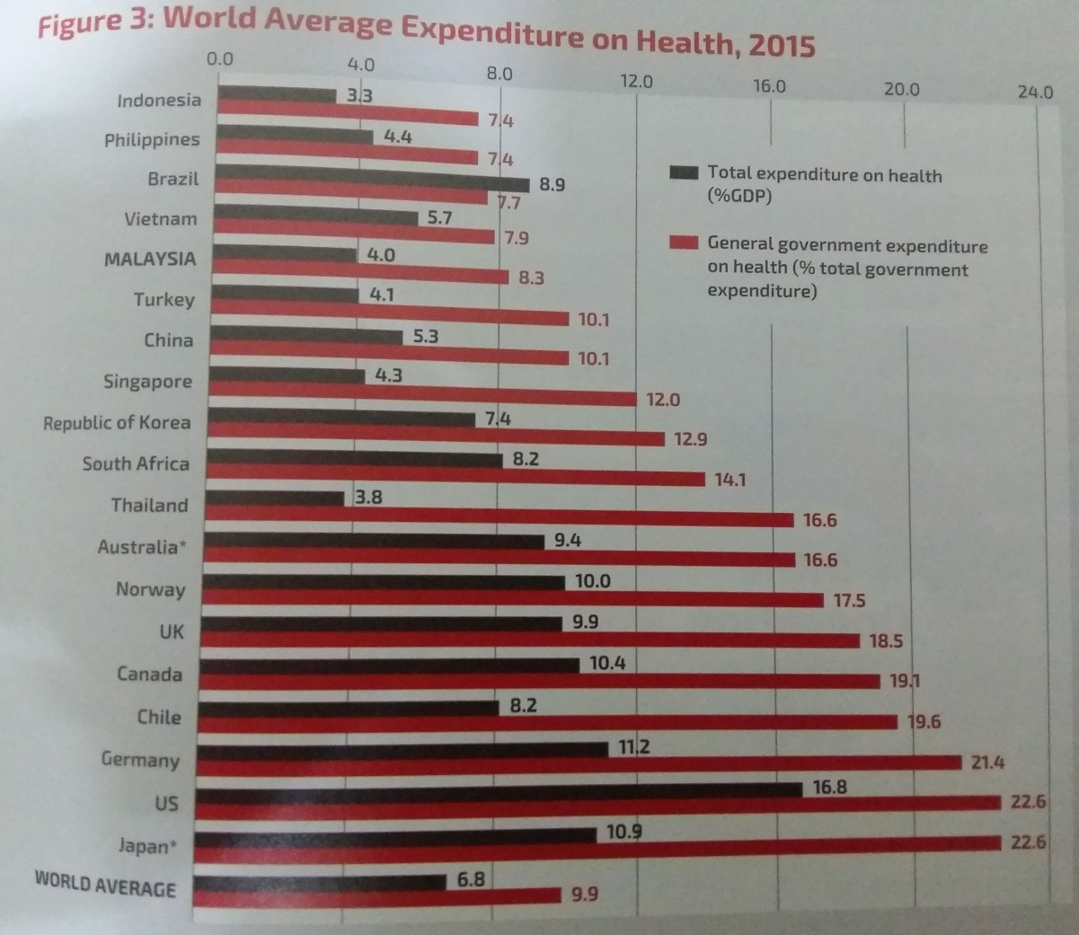
(Source: Penang Monthly May 2018)

3. Declare a Moratorium on the building of new private hospitals as these will continue to suck away specialists from the government sector. This Moratorium could be lifted once a better balance in deployment of our specialist doctors is achieved.

4. Introduce a new Service Commission for Health Care Personnel in Government Service with features that will help retain senior and experienced people
- Perhaps the pay scheme in UJN can be adopted
- Give 3 month sabbaticals to specialists every 5 years of service so that they can go overseas and pick up new skills and procedures.
- Give enhanced pension for those specialists who put in 20 years or more of service in the government sector.

Would this make our B40 lazy?
This might be what some Malaysians might think. But at the PSM we believe differently. Apart from the “externalities” that I mentioned above, one other reason is that Malaysia is trapped in a low wage economy where ordinary workers are paid much less than their compatriots in advanced countries despite having similar productivity. The slide below contrasts the wages of our school cleaner with that of an Australian. There is a 10 fold difference. Even if the cost of living in Australia is 3x ours, real income for a cleaner in Australia is still 3x higher than for our cleaner.

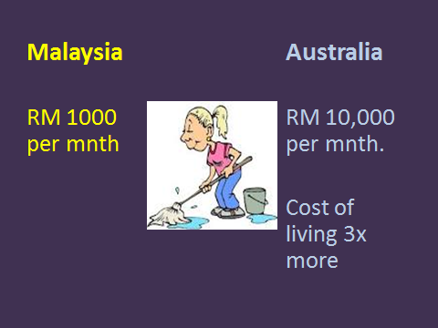

Similarly in our factories –

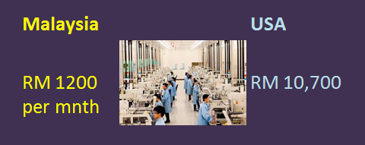

Workers in the electronic factories in Bayan Lepas receive about an eight of the pay of a worker in an US factory in California even if they are producing the same component product. This differential has little to do with “productivity” (as the World Bank and IMF would like us believe) but is due largely to the “market power” of the large firms outsourcing production of components to developing countries. (But this is not the place to go into a detailed discussion of that!)

Since we are unable to pay fair monetary wages to our workers given our subservient position in the international economic system, the least we can do is to provide them essential services – health, education, public transport - at subsidized rates. A sort of “social wage”.

I hope I have been able to communicate the reasons why the PSM sometimes takes a contrary position to the mainstream – it stems from a different understanding of the current situation. I would like to hear responses from the audience.

Thank you

Jeyakumar Devaraj
Parti Sosialis Malaysia

